

Practices for Secure Software Report

Table of Contents
Practices for Secure Software Report 1
Document Revision History 3
Client 3
Developer 4
1. Algorithm Cipher 4
2. Certificate Generation 4
3. Deploy Cipher 5
4. Secure Communications 6
5. Secondary Testing 8
6. Functional Testing 9
7. Summary 10
8. Industry Standard Best Practices 11
9. References 12

Document Revision History

Version | Date | Author | Comments
1.0 | 2026-10-18 | Landon Allanson | Initial report

Client



Developer
Landon Allanson

Algorithm Cipher

I went with SHA-256 for Artemis Financial’s checksum, with HTTPS protecting the connection. Artemis Financial wants a data verification step whenever data moves through its web app. The two risks are someone changing the data in transit or someone reading it. SHA-256 handles the first, and HTTPS handles the second. Strictly speaking, SHA-256 isn’t a cipher: there’s no key, and it can’t be decrypted. It just creates a unique fingerprint of the data.

Overview: SHA-256 is part of the SHA-2 family, designed by the NSA and standardized by NIST in FIPS 180-4. It turns any input into a fixed 256-bit value. It’s one-way, and changing even one character changes the entire result, so any tampering is easy to identify. It’s also built into Java (every Java platform is required to support it), so no extra libraries were needed.

Hash functions and bit levels: The output is 256 bits. That gives about 256 bits of security against someone working backward from a hash. It gives roughly 128 bits against someone finding two inputs with the same hash (a collision). Both are well beyond what can be brute-forced today. Older options like MD5 (128-bit) and SHA-1 (160-bit) have been broken, so they’re off the table. My certificate uses hashing too: it’s signed with SHA-256 and RSA over a 2048-bit key.

One limit, though, is that a checksum only proves the data wasn’t changed if the checksum itself can be trusted. If an attacker could swap both the data and its hash, they’d still match. Here, HTTPS protects the hash in transit. If Artemis Financial ever sends checksums over a channel it doesn’t control, HMAC-SHA-256 (a keyed hash) or a digital signature would close that gap.

Random numbers, symmetric vs. asymmetric keys: SHA-256 doesn’t use keys or random numbers, since it needs to give the same answer every time for verification to work. Randomness does matter elsewhere, like generating my RSA key pair and the session keys for each HTTPS connection.

HTTPS uses both kinds of cryptography. Asymmetric cryptography (public/private key pairs) handles the handshake. My RSA certificate proves who the server is, and a key exchange creates a shared session key. Symmetric encryption, which is much faster, then uses that shared key to encrypt the actual traffic. In my testing, Firefox reported the connection as “Connection Encrypted (TLS_AES_128_GCM_SHA256, 128-bit keys, TLS 1.3.” That means the traffic itself is encrypted.

History and current state: DES, the old 56-bit standard from 1977, was cracked in 1998 and replaced by AES in 2001. Hash functions have gone the same way. MD5 was broken in 2004 and SHA-1 in 2017, and NIST wants SHA-1 effectively gone by the end of 2030 (National Institute of Standards and Technology [NIST], 2022).

The biggest focus now is quantum computing. In 2024, NIST released its first post-quantum standards to replace algorithms like RSA (NIST, 2024). Quantum attacks roughly halve a hash’s effective strength rather than breaking it outright, so SHA-256 still has a comfortable margin and remains a valid choice.

Certificate Generation

I used the JDK’s keytool to create a 2048-bit RSA key pair and a self-signed certificate signed with SHA256withRSA. It’s stored in a PKCS12 keystore under the alias tomcat. I also added Subject Alternative Names for localhost and 127.0.0.1, since modern browsers check those instead of the Common Name when matching a certificate to a site.

Then I exported the certificate as server.cer and printed it with keytool -printcert to confirm the details. It’s issued to and by me, which is what “self-signed” means, and it’s valid for one year. That’s fine for development, but a real production site should use a certificate from a trusted certificate authority.

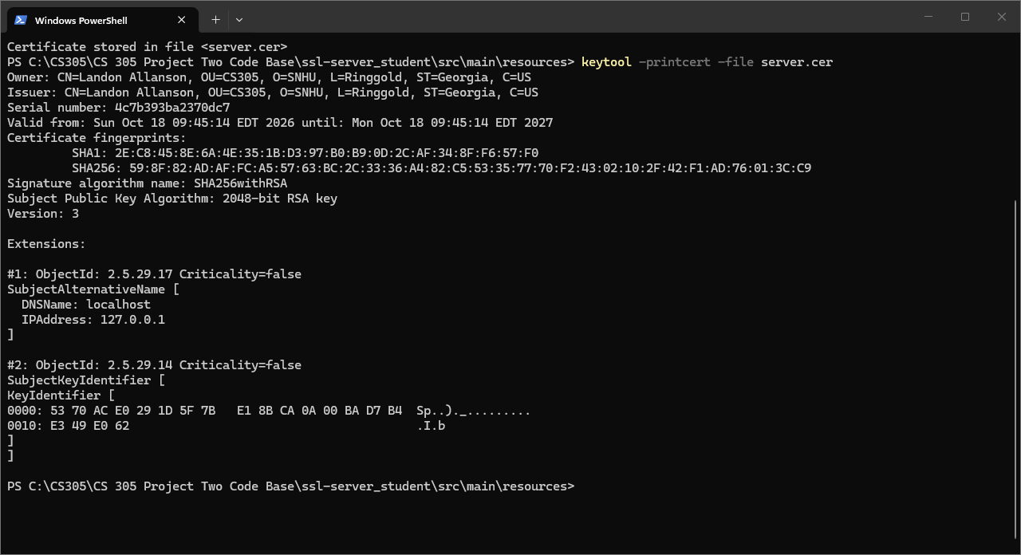

Deploy Cipher

I added a /hash route to SslServerApplication.java, taking care of the FIXME in the original code. It runs a data string containing my name through SHA-256 using Java’s MessageDigest class. It then displays the data, the algorithm name, and the checksum as a hex string. I convert the string to bytes using UTF-8 explicitly, so the checksum comes out the same on any machine.

To verify data, the receiver runs it through SHA-256 as well and compares the two results. If anything changes, even one character, they won’t match.

To double-check, I hashed the same string separately in PowerShell and got the same value.

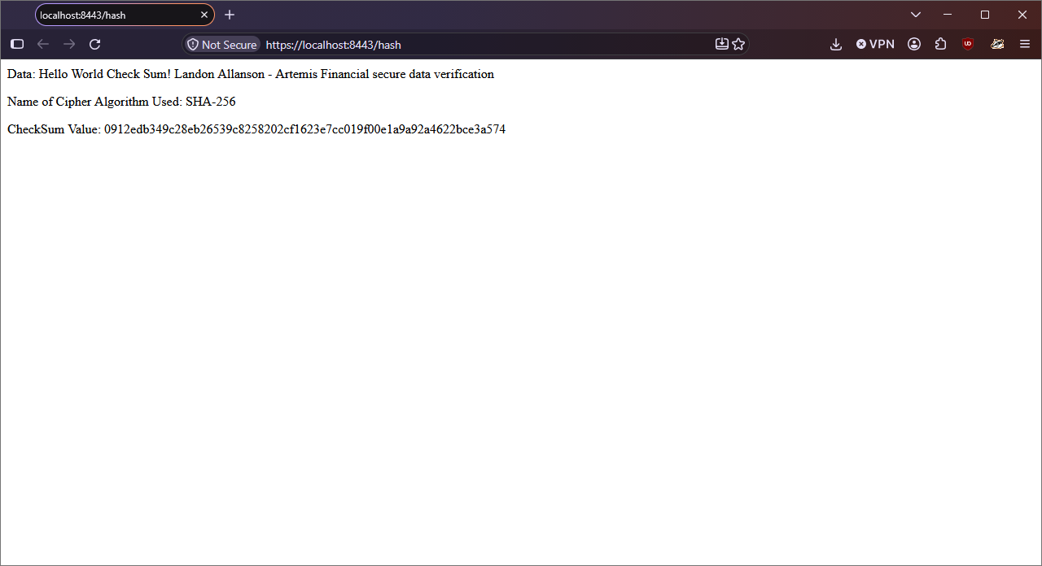

Secure Communications

I filled in the four missing SSL settings in application.properties: key alias, keystore location, keystore type, and password. The app now only runs over HTTPS on port 8443, with no plain HTTP port to fall back to. Going to https://localhost:8443/hash loads the checksum page over an encrypted connection.

Firefox’s certificate viewer confirms the server is presenting my certificate, and its connection details show “Connection Encrypted.” Firefox still says “Not Secure,” but only because the certificate is self-signed and no certificate authority has vouched for it. The connection itself is still encrypted.

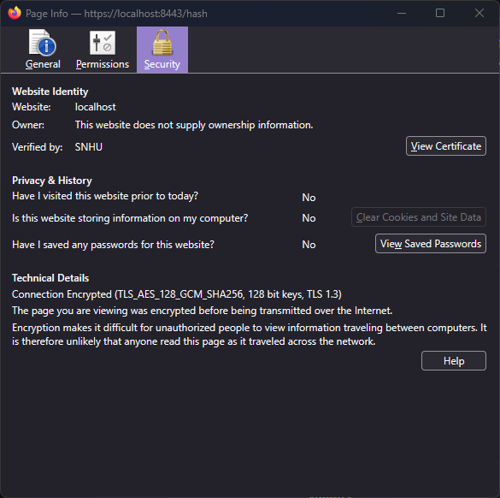

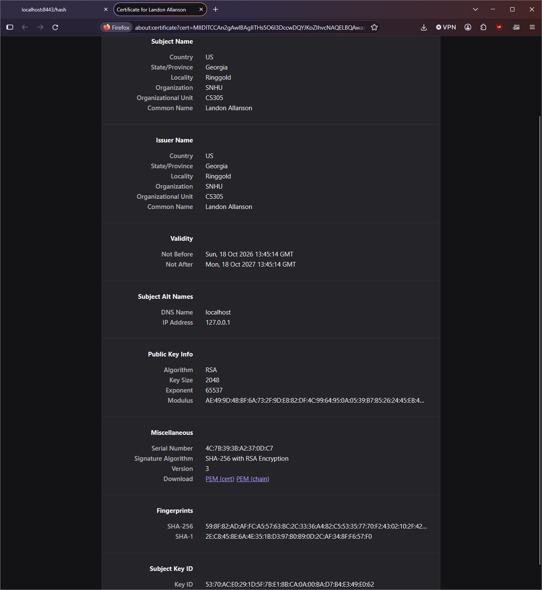

Secondary Testing

The original dependency-check plugin (5.3.0) is outdated and can’t download vulnerability data anymore, so I updated it to version 13.0.0. I ran the scan before and after my changes, and the results were identical: 49 dependencies scanned, 14 vulnerable dependencies, and 254 vulnerabilities found. I kept the baseline report in the project folder (baseline-dependency-check-report.html) for comparison.

All of those come from libraries Spring Boot 2.2.4 already included. The worst ones:

- tomcat-embed-core and tomcat-embed-websocket 9.0.30: 76 and 77 findings, both critical. These are mostly the same Tomcat issues counted twice, since both jars match the same CPE.
- spring-web and spring-core 5.2.3: 30 and 29 findings, critical.
- snakeyaml 1.25: critical.

My changes didn’t add any dependencies, so they didn’t add any vulnerabilities. Fixing the existing ones means upgrading Spring Boot, and probably Java along with it. I’d recommend that as a separate project since it touches the entire application.

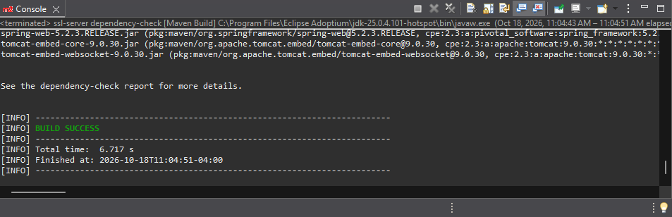

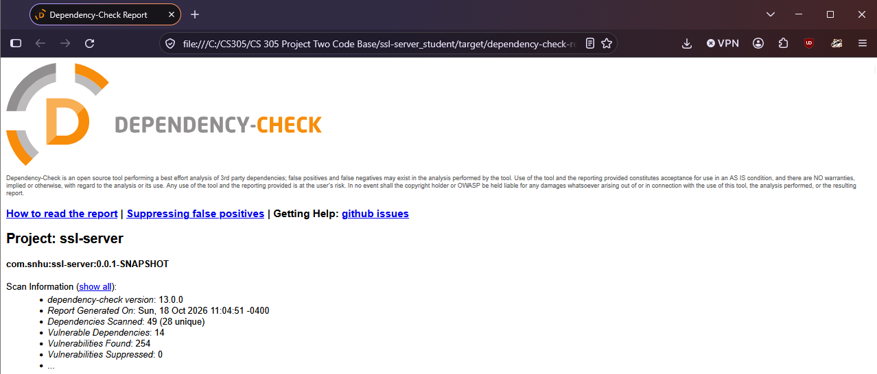

Functional Testing

I went through my changes line-by-line checking for errors, then ran the application and fixed things until it ran cleanly.

Type | Problem | Fix
Syntax | Checked new code and keys for typos, missing imports, and wrong annotations | None in final code; Eclipse and Maven both compile it cleanly
Build/Compile (Eclipse) | Eclipse compiled for Java 25, which Spring Boot 2.2.4 can’t read | Set compiler compliance to Java 1.8
Logic | No checksum route, just a FIXME | Added /hash
Logic | Hashing could depend on the device’s default text encoding | Used UTF-8 explicitly
Logic | MessageDigest isn’t thread-safe, so sharing one across requests could give wrong results | Kept it local to the method, so each request gets its own
Configuration | “????” placeholders in application.properties | Filled out the SSL settings
Error handling | /hash declares NoSuchAlgorithmException | Realistically can’t happen since Java must support SHA-256; if it did, Spring returns a generic error page
Security | Weak hashes (MD5, SHA-1) | Used SHA-256
Security | Plain HTTP | HTTPS only
Security | Unused spring-boot-starter-data-rest dependency adds attack surface and brings in spring-data-rest-core (high) and spring-hateoas (medium) findings | Recommend removing and re-scanning
Remaining | Spring Boot libraries outdated, plaint-text keystore password, self-signed certificate | Upgrade Spring Boot, store the password in an environment variable, and use a CA-signed certificate in production

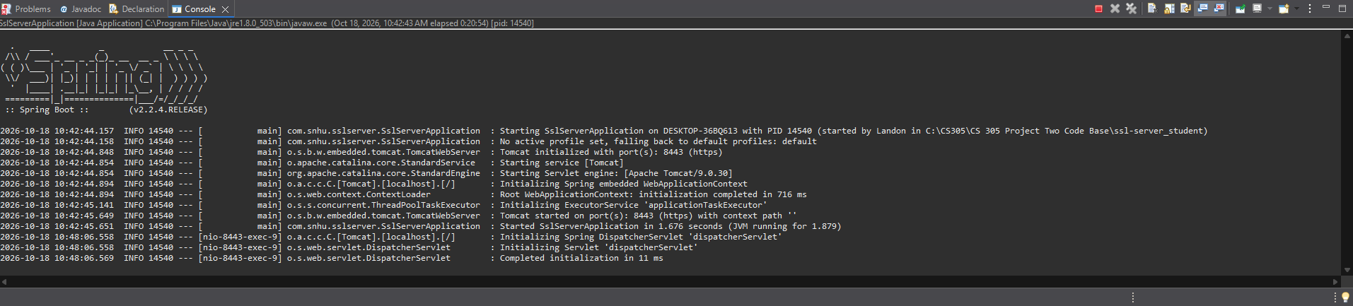

Summary

I followed the vulnerability assessment process flow from top to bottom:

- Architecture Review: The app is small. One application class, one REST controller, and no database or data layer. That told me which code reviews mattered.
- Input Validation: The /hash route takes no user input, so there’s nothing to inject. If Artemis Financial later hashes uploaded files, those should be checked for size and type first.
- APIs: The new /hash route is read-only and GET-only.
- Cryptography: SHA-256 for the checksum and a 2048-bit RSA certificate for HTTPS.
- Client/Server: HTTPS only, on port 8443.
- Code Error: The only possible exception can’t realistically happen, and Spring returns a generic error page if it ever did.
- Code Quality: Standard Java crypto instead of custom code, explicit UTF-8, and updated tooling.
- Encapsulation: ServerController is package-private, and the data and MessageDigest live inside the method, so nothing is shared between requests.

From there, the diagram says the architecture review and static testing decide which manual code reviews are needed. For this app, that meant:

- Controllers: ServerController
- APIs: /hash
- Plugins: the dependencies and plugins in pom.xml

Views, Models, Data Access, and Services don’t exist in this application, so there was nothing to review there. The Functional Testing table is my summary of findings with a mitigation plan, which is the last step in the flow.

I added security in layers:

- encryption in transit with HTTPS
- a checksum for data integrity
- dependency scanning to catch known vulnerable libraries
- manual review to catch what the scanner can’t

Whenever something broke, I fixed it and tested again until the app ran cleanly and the scan showed no new vulnerabilities.

Industry Standard Best Practices

Maintaining existing security: I stuck with Java’s built-in crypto instead of writing my own, and I followed NIST guidance by using SHA-256 instead of SHA-1 (NIST, 2022). My changes line up with three OWASP Top 10:2025 categories (OWASP Foundation, 2025):

- Cryptographic Failures: strong hashing and HTTPS.
- Software or Data Integrity Failures: the checksum lets Artemis Financial confirm data hasn’t been altered.
- Software Supply Chain Failures: I scanned dependencies for known vulnerabilities.

I also only changed what I needed to and didn’t add any new dependencies. Afterward, I re-ran the original test and the scan to make sure nothing broke and nothing new was introduced.

Value to the company: Artemis Financial handles sensitive client data, like savings, retirement, and investment plans. The FTC Safeguards Rule requires financial companies to encrypt customer information in transit (Federal Trade Commission [FTC], 2022). The average data breach now costs a record $4.99 million USD (IBM, 2026).

Following best practices helps avoid that, keeps client trust, and is much cheaper than cleaning up after a breach. Global Rain’s motto is that security is everyone’s responsibility, and building it in from the start is a lot easier than adding it later.

References

Federal Trade Commission. (2022). FTC Safeguards Rule: What your business needs to know. https://www.ftc.gov/business-guidance/resources/ftc-safeguards-rule-what-your-business-needs-know

IBM. (2026). Cost of a data breach report 2026. https://www.ibm.com/reports/data-breach

National Institute of Standards and Technology. (2022, December 15). NIST retires SHA-1 cryptographic algorithm. https://www.nist.gov/news-events/news/2022/12/nist-retires-sha-1-cryptographic-algorithm

National Institute of Standards and Technology. (2024, August 13). NIST releases first 3 finalized post-quantum encryption standards. https://www.nist.gov/news-events/news/2024/08/nist-releases-first-3-finalized-post-quantum-encryption-standards

OWASP Foundation. (2025). OWASP Top 10:2025. https://top10.owasp.org/2025/

